**WeCare-Online Life Coaching**

**WeCare**is an online Life Coaching application that helps its users to sign up and log in to seek the guidance of famous Life Coaches. Users can search for a Life Coach based on specialty and can book an appointment within 7 days. They can also see upcoming appointments and can reschedule or cancel the appointments. Similarly, Life Coaches can also sign up and login and can see their upcoming schedule.

* HTML5,CSS3,Javascript for frontend development.
* JSON file is used as the database and AJAX/fetch() API for communication.(This is optional, you can use Javascript/JSON Array and Objects too)

**List of Software’s Required:**

* Visual Studio Code IDE
* SCSS
* Node

**1. Home Screen**

Below view should be displayed.

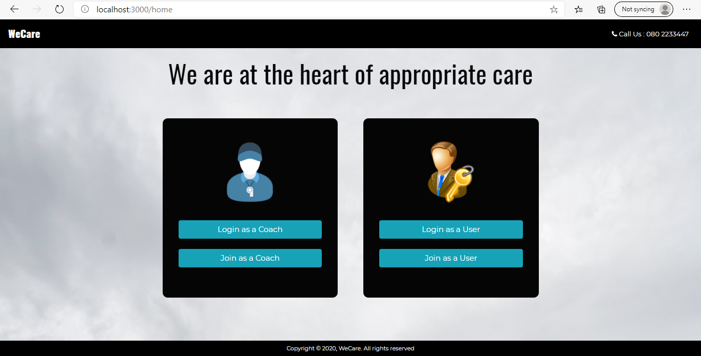

* The navigation bar should have brand icon and call us by default (before login).
* On click of ‘Join as a Coach’ button Coach Signup page should be loaded.
* On click of ‘Login as a Coach’ button Coach Login page should be loaded.
* On click of ‘Join as a User’ button User Signup page should be loaded.
* On click of ‘Login as a User’ button User Login page should be loaded.

**2. Coach Signup Screen**

This screen should render a Coach signup page for coaches to register into the application.

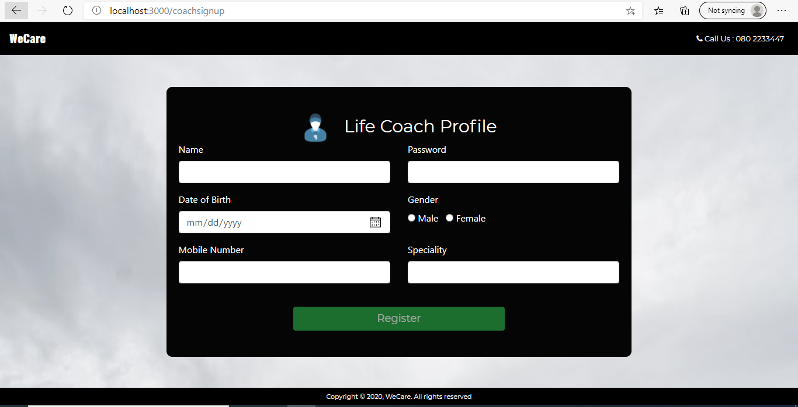

| **Name** | **Properties** |
| --- | --- |
| name | Name should have 3 to 50 characters |
| password | Password should have 5 to 10 characters |
| dateOfBirth | Age should be between 20 and 100 years |
| gender | required |
| mobileNumber | Mobile Number should have 10 digits |
| speciality | Speciality should have 10 to 50 characters |

* If any validation fails, display the error message as shown below:

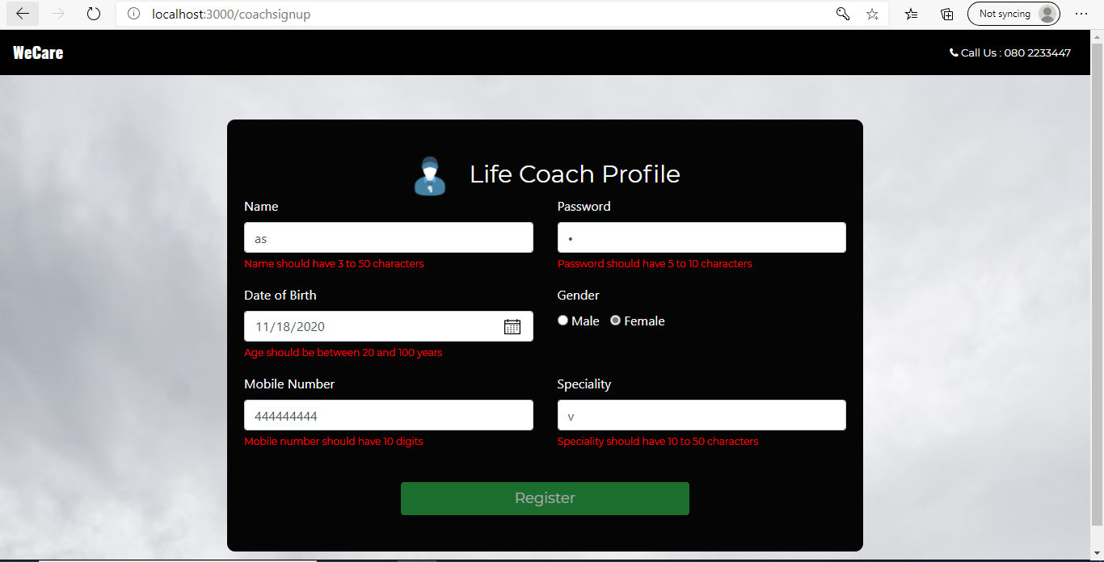

When the user clicks on register button after entering the values, send a post request to a json file with Ajax and pass the collected data. If the registration is success make the below page rendered and code should be written in the same component.

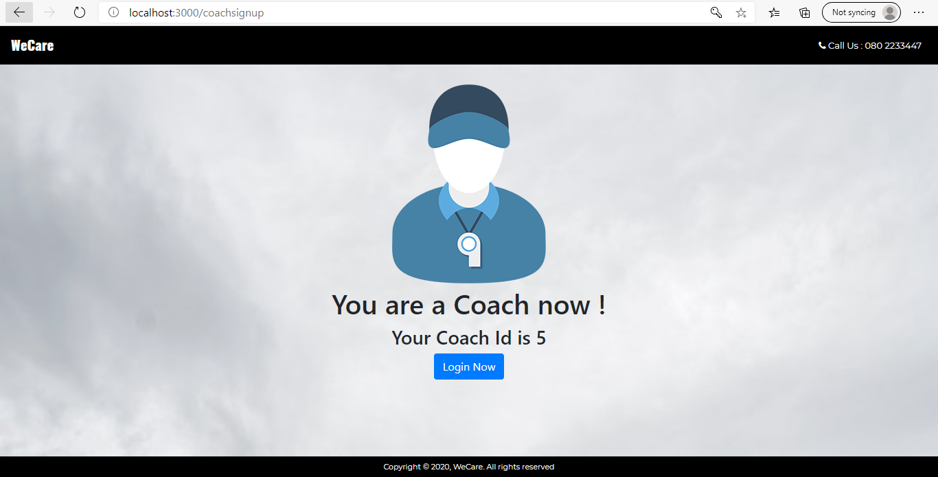

On click of ‘Login Now’ it should load coach login page.

**3. Coach Login Screen**

This screen should render a Coach login page for coaches to login into the application.

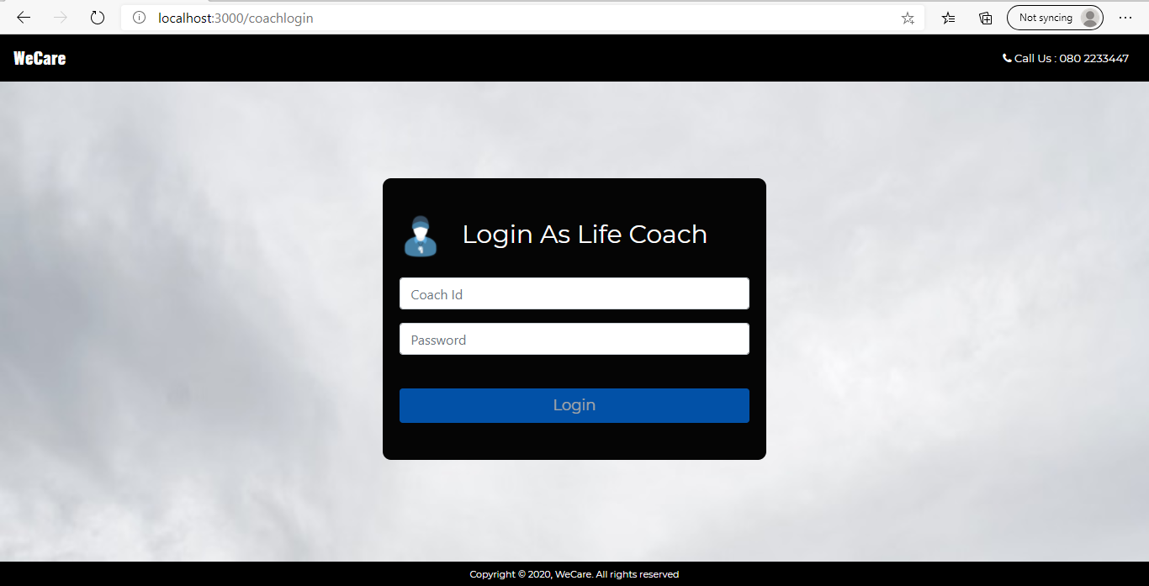

| **Name** | **Validations** |
| --- | --- |
| id | required |
| password | Password should have 5 to 10 characters |

* If any validation fails, display the error message as shown below:
* 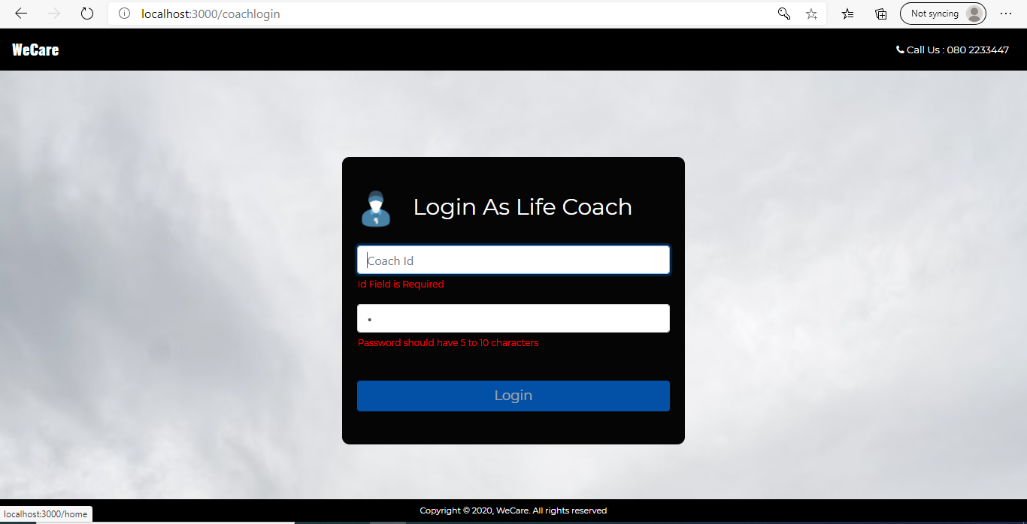
* When the user clicks on login button after entering the values, send it to a new page by checking the username and password. Here to check the username and password you can have your javascript array of user objects.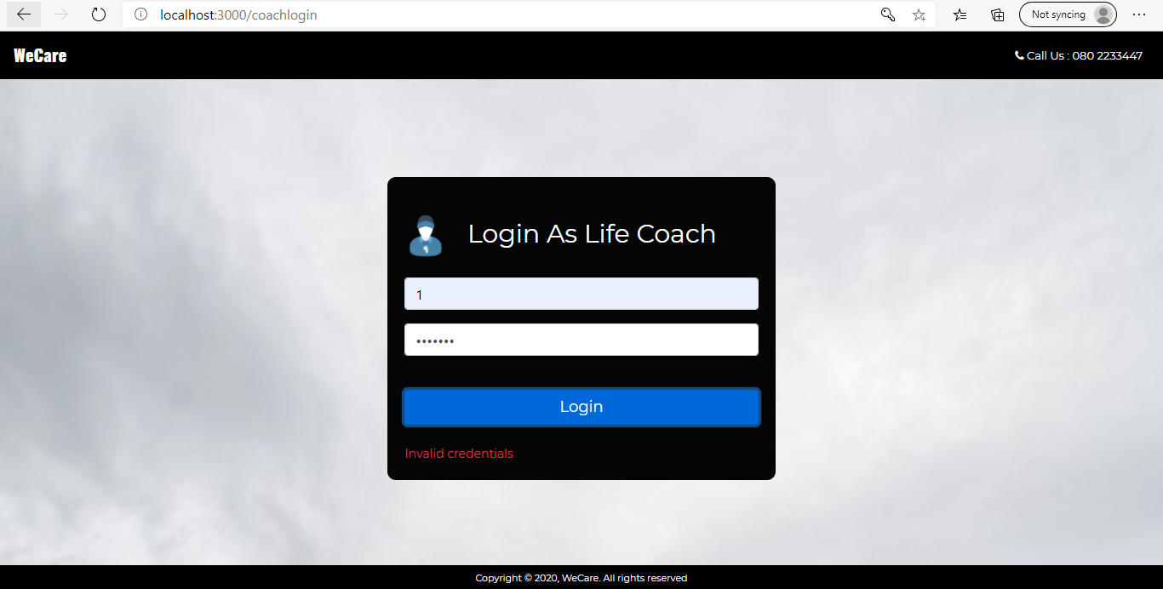

On successful login make Coach home page loaded.

**4. User Signup Screen**

This screen should render a User signup page for user to register into the application.

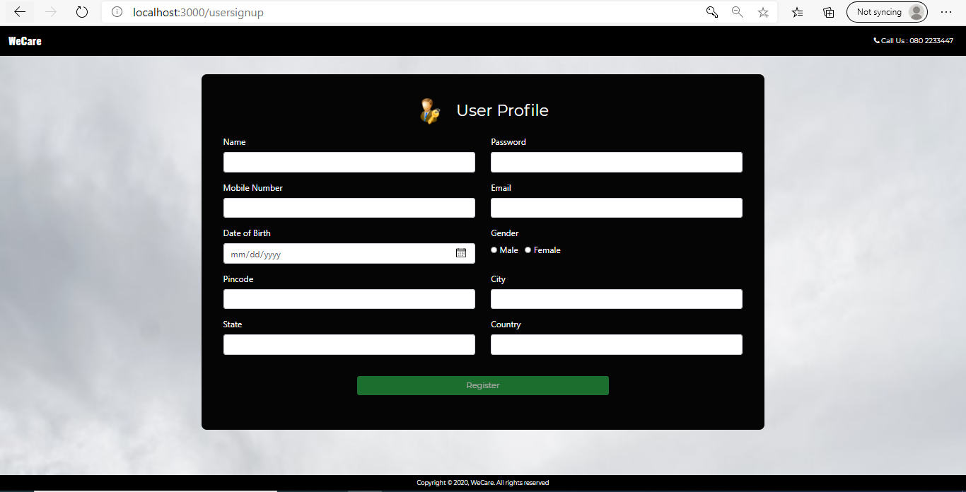

| **Name** | **Validations** |
| --- | --- |
| name | Name should have 3 to 50 characters |
| password | Password should have 5 to 10 characters |
| mobileNumber | Mobile Number should have 10 digits |
| email | Required |
| dateOfBirth | Age should be between 20 and 100 years |
| gender | required |
| pincode | Pincode should have 6 digits |
| city | City should have 6 to 20 characters |
| state | State should have 6 to 20 characters |
| country | Country should have 6 to 20 characters |

If any validation fails, display the error message as shown below:

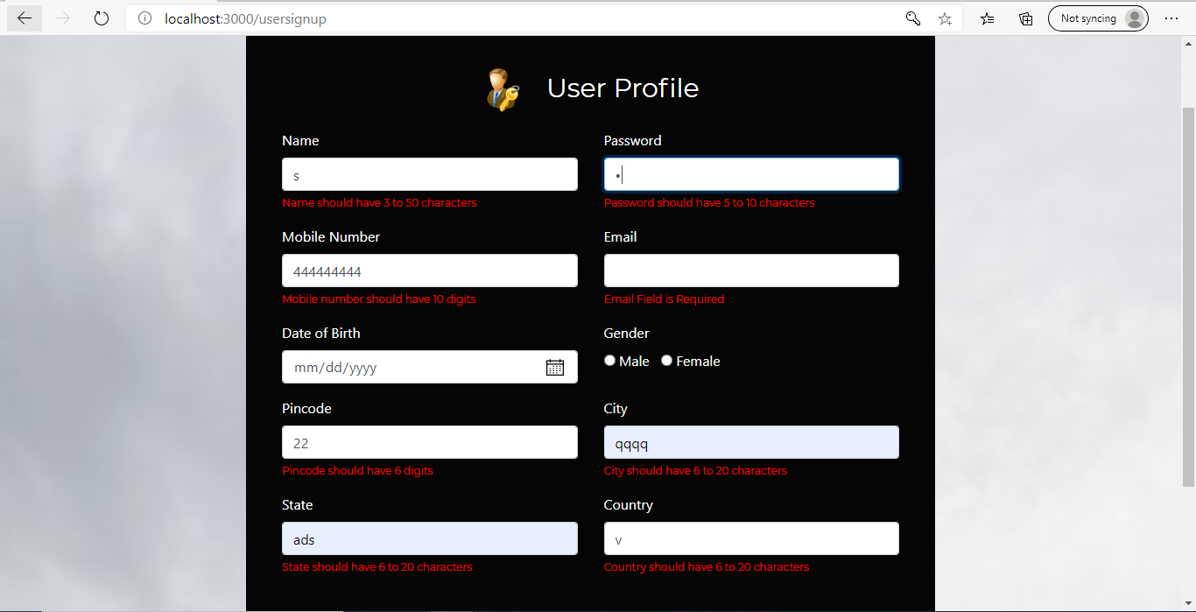

When the user clicks on register button after entering the values save this data in an array.

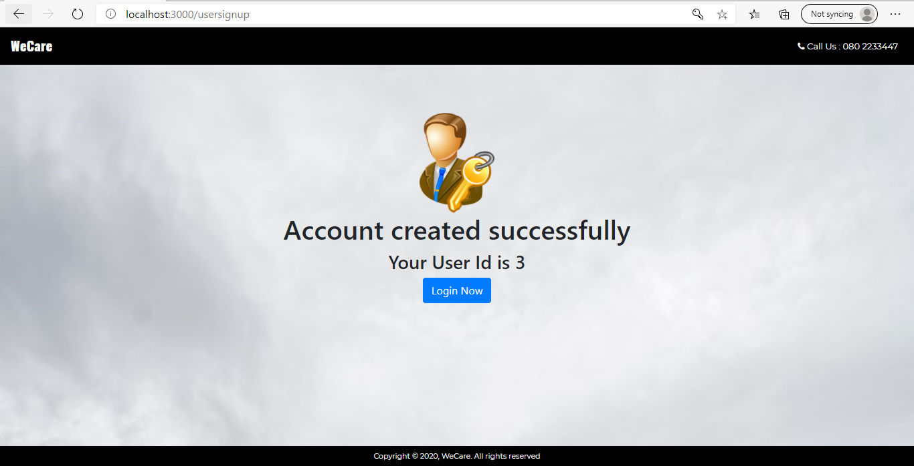

On click of ‘Login Now’ it should load User login page.

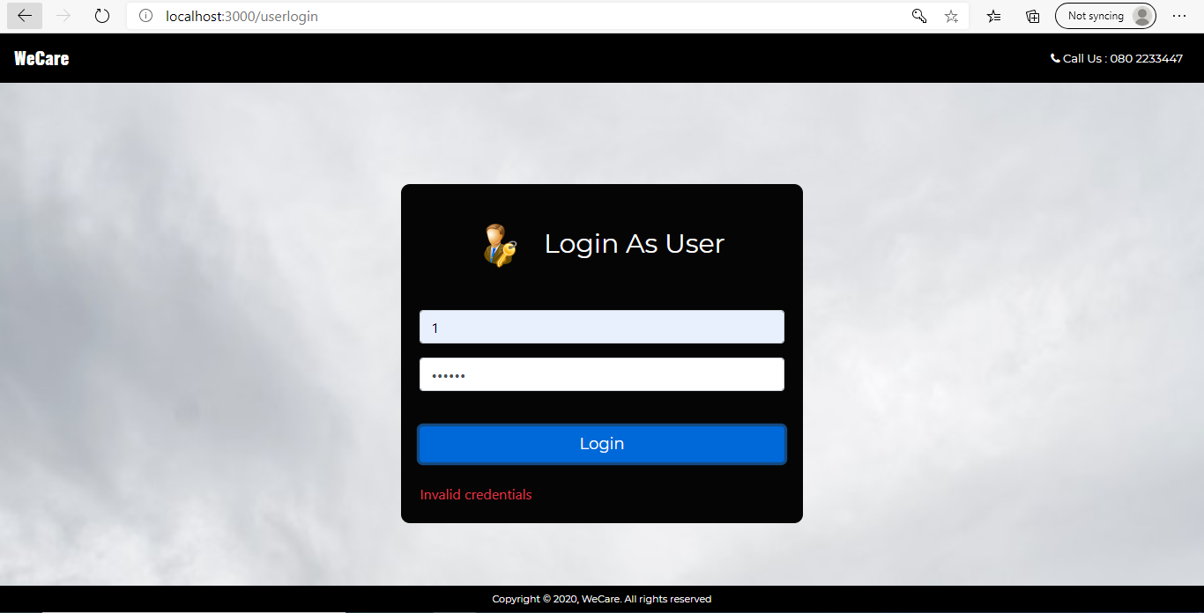

**6. Coach Home Screen**

This screen should render the Coach home page. On load of this page it should render the below screen. Navbar should be updated as shown below in screenshot.

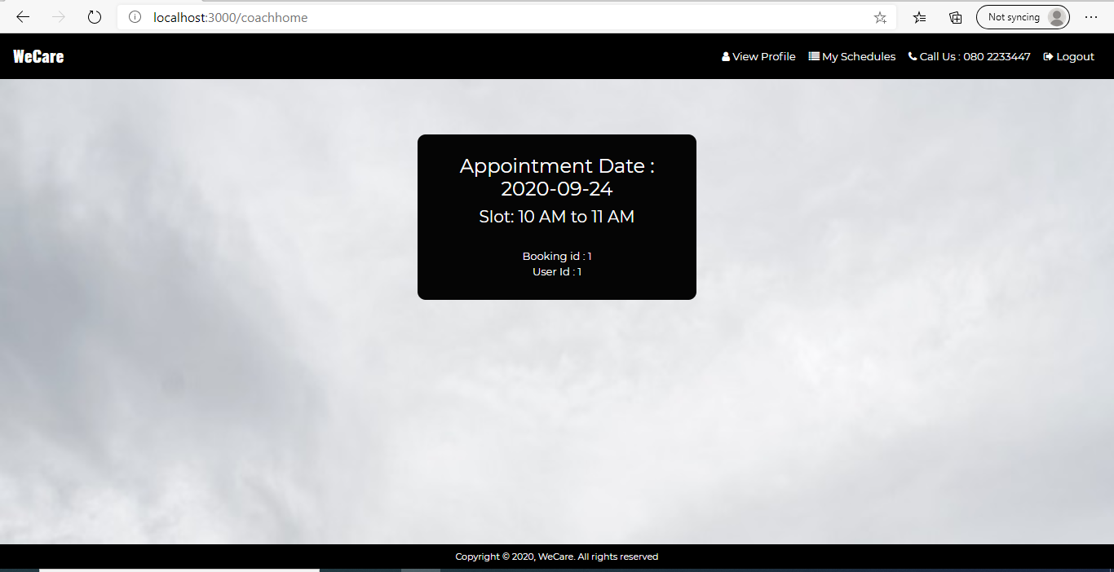On load of this component,

1.       Send a get request using AJAX and populate appointment details with the success return value.

2.       Send another get request using AJAX to populate coach details with the success return value.

On clicking navbar links it should show schedule details and coach details appropriately as shown in the below screenshots.

On clicking My Schedules link it should display the below page:

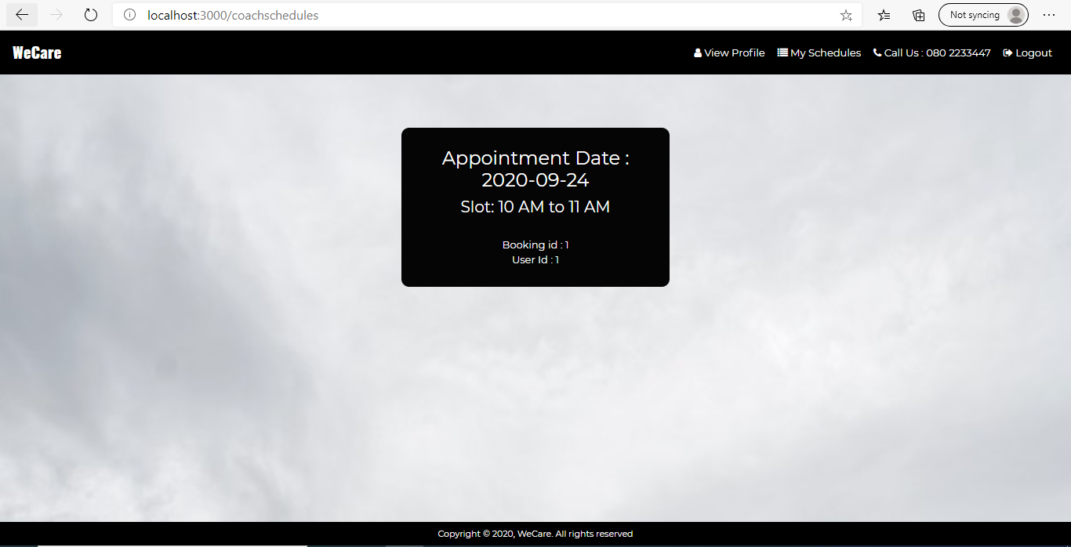

On clicking View Profile link it should display the below page:

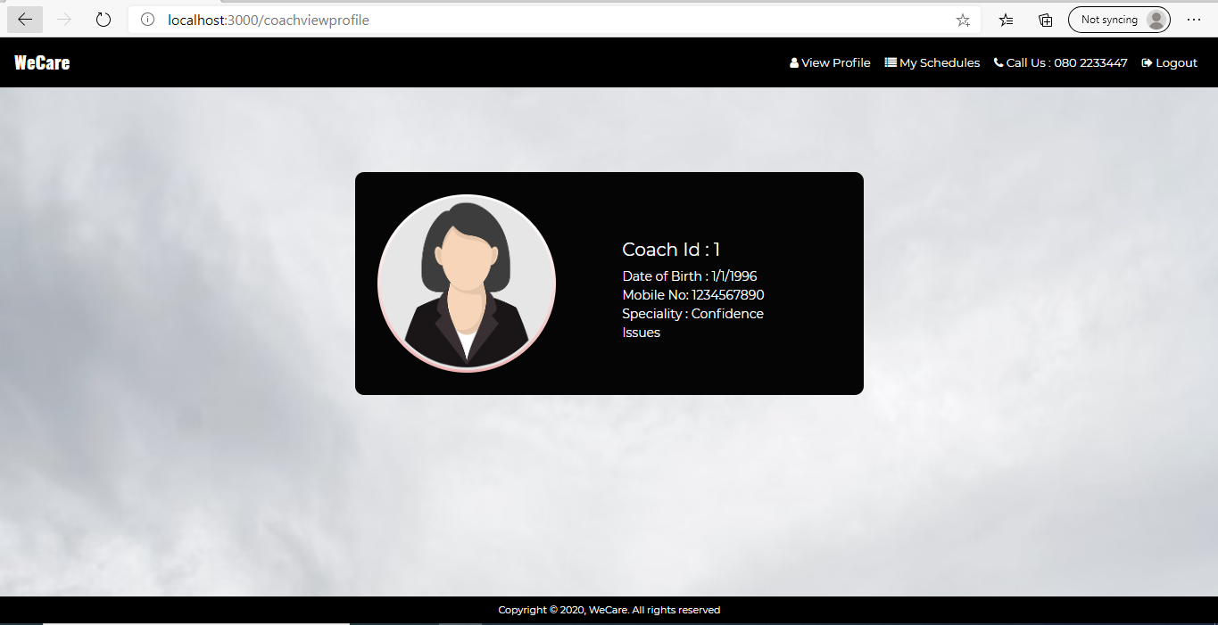

On load of /coachhome and /coachschedules it should show schedule details initially if any. If not, schedules fixed yet, the below display should be shown:

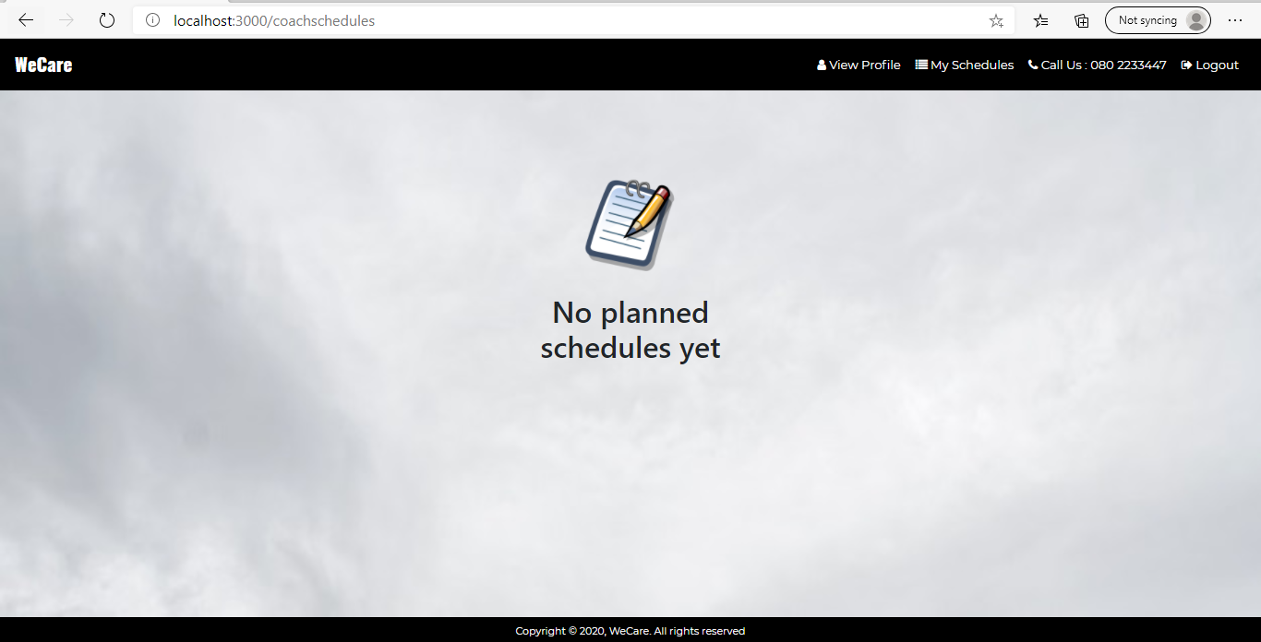

**7. User Home Screen**

This screen should render the User home component. On load of this component it should render the below page. Navbar should be updated as shown below in screenshot.

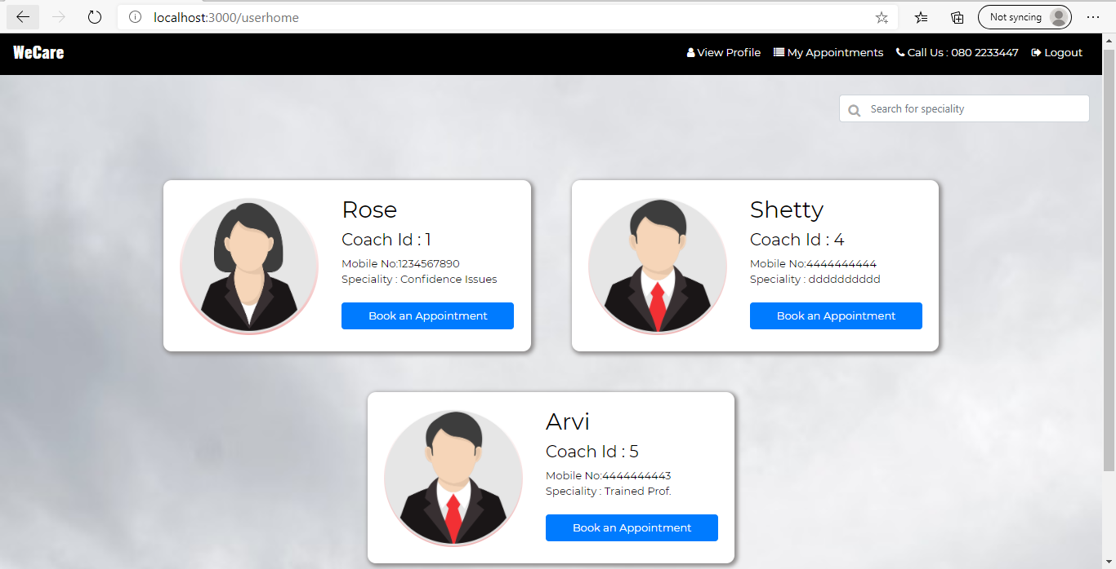

On load of this component,

1. Define a coach array .
2. Define a user details object to get user details.
3. Define a appointment array.

On clicking navbar links it should show appointment details and user details appropriately. On load it should show coach array initially as shown above.

On clicking View Profile link it should display the below page:

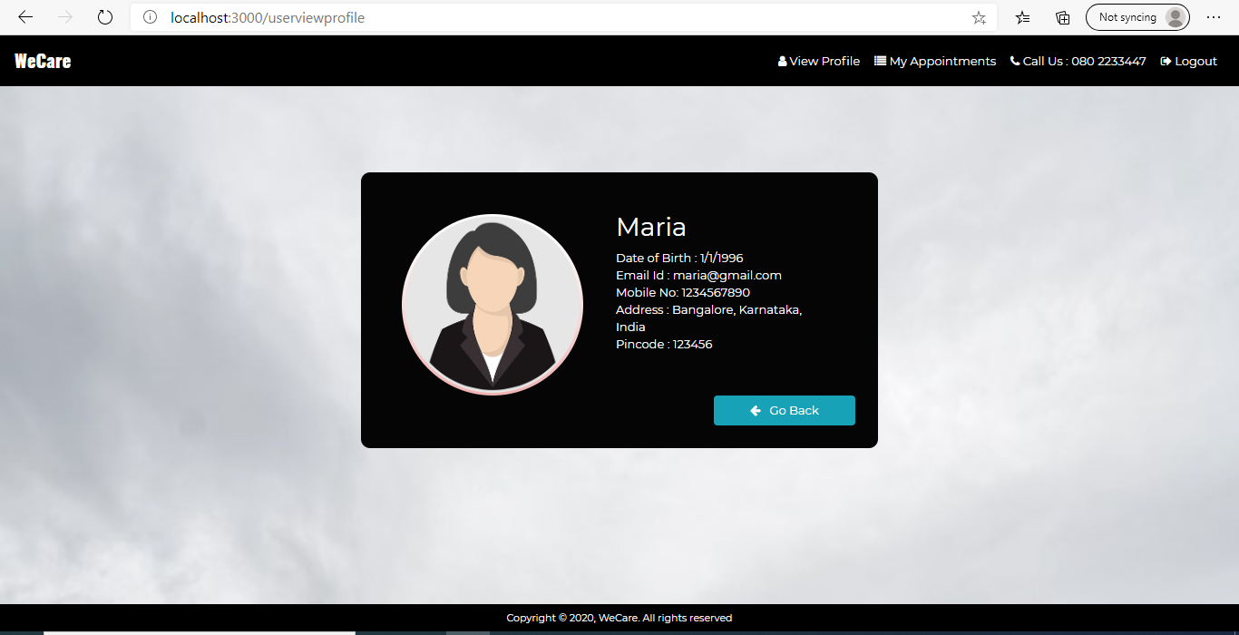

On clicking My Appointments link it should display all the appointments made by the user as shown below.

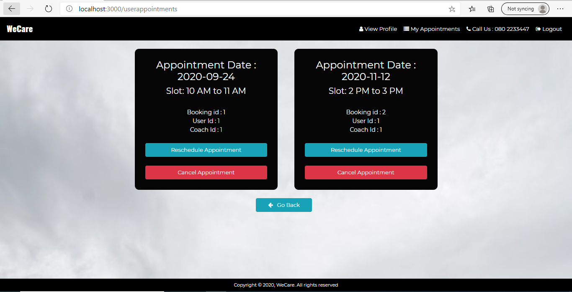

**7. User Home Screen**

On click of Book Appointment button on any coach Card below page should be shown:

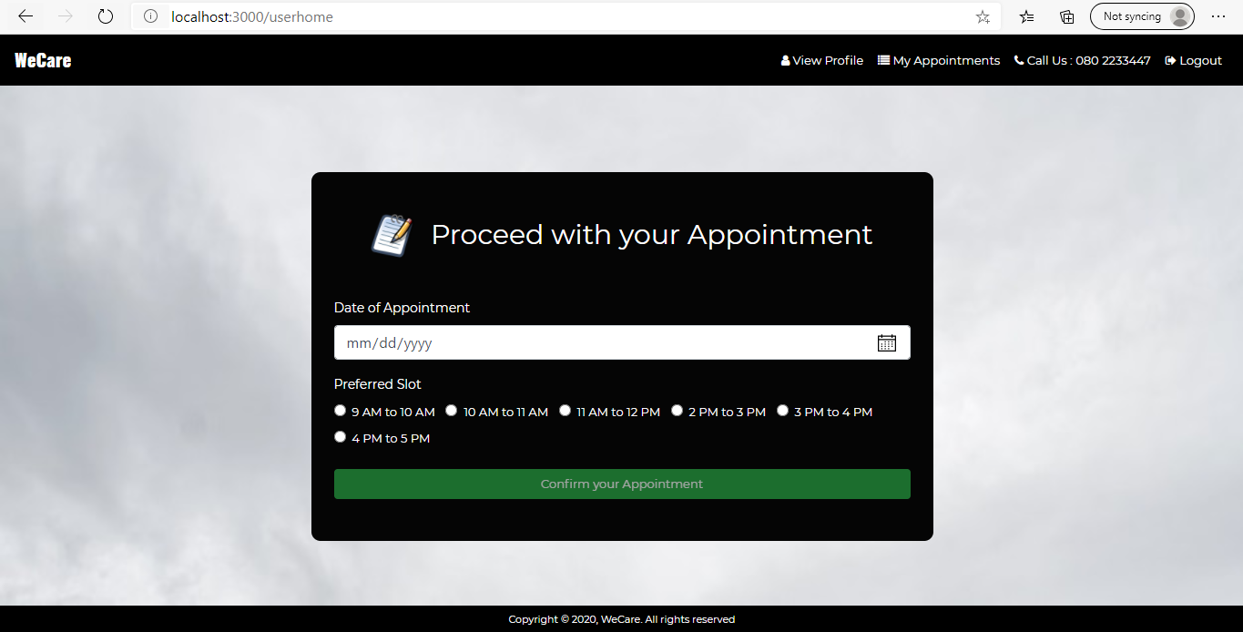

| **Name** | **Validations** |
| --- | --- |
| DateOfAppointment | Required, date should be any upcoming 7 days |
| Slot | required |

Button will be disabled until all validations are satisfied. On click of Confirm your Appointment it should show some success message.

If any validation fails, display the error message as shown below:

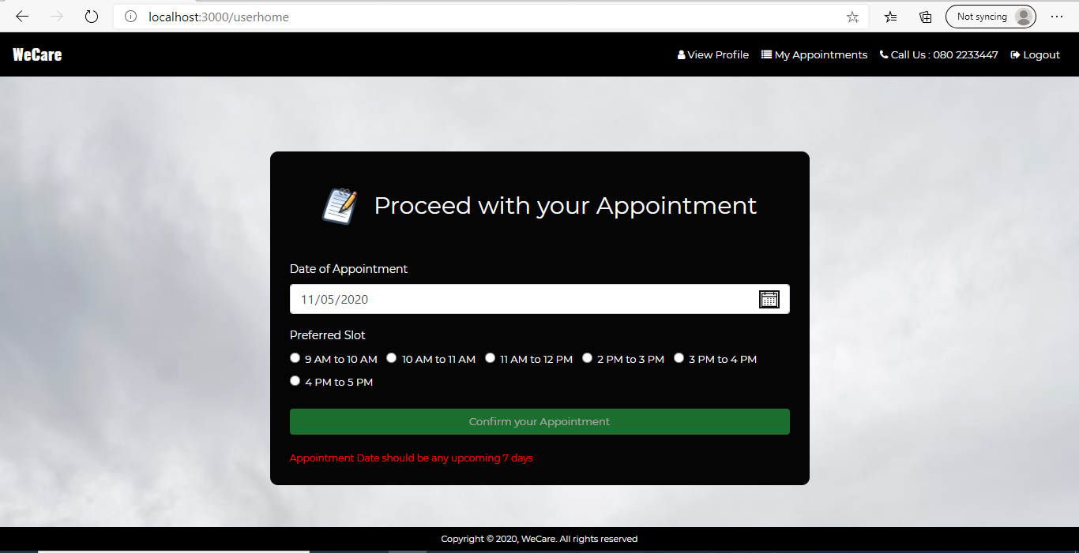

On successful making of any appointment show the below page:

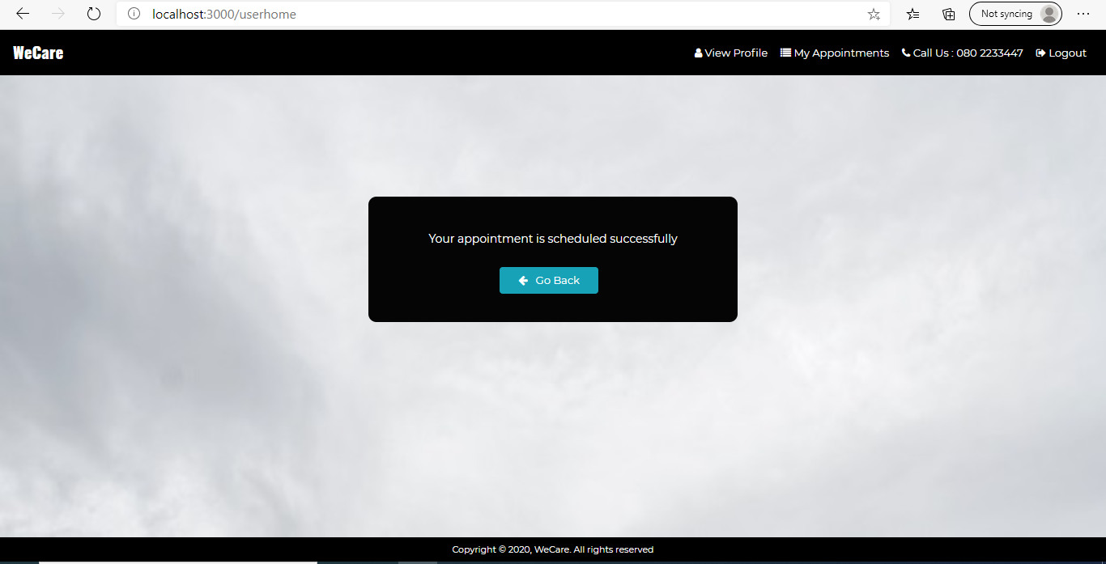

On clicking the go back button, it should navigate to userhome page where it displays the list of coaches.

**7. User Home Screen**

On click of Reschedule Appointment Button on the userappointment display the below page:

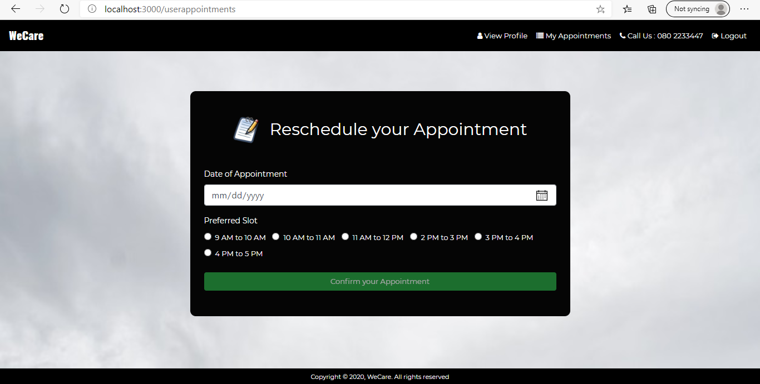

| **Name** | **Validations** |
| --- | --- |
| DateOfAppointment | Required, date should be any upcoming 7 days |
| Slot | required |

Button will be disabled until all validations are satisfied. On click of Confirm it should show a success message.

If any validation fails, display the error message as shown below:

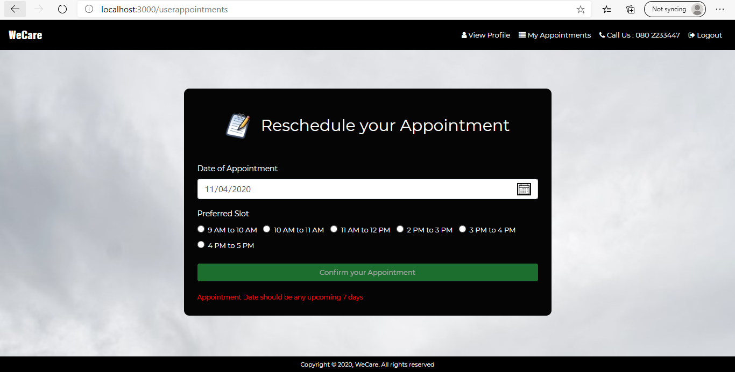

On successful rescheduling show the below page:

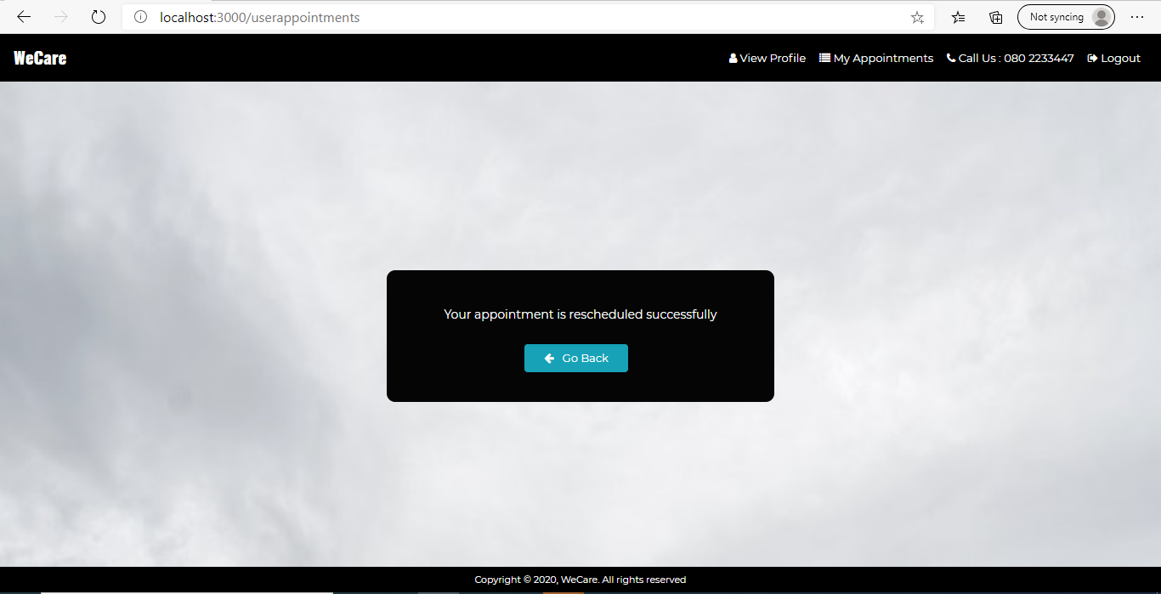

On clicking the go back button, it should navigate to userhome page where it displays the list of coaches.

On click of cancel Appointment Button on userappointment, it should invoke a model which is shown in the below screenshot.

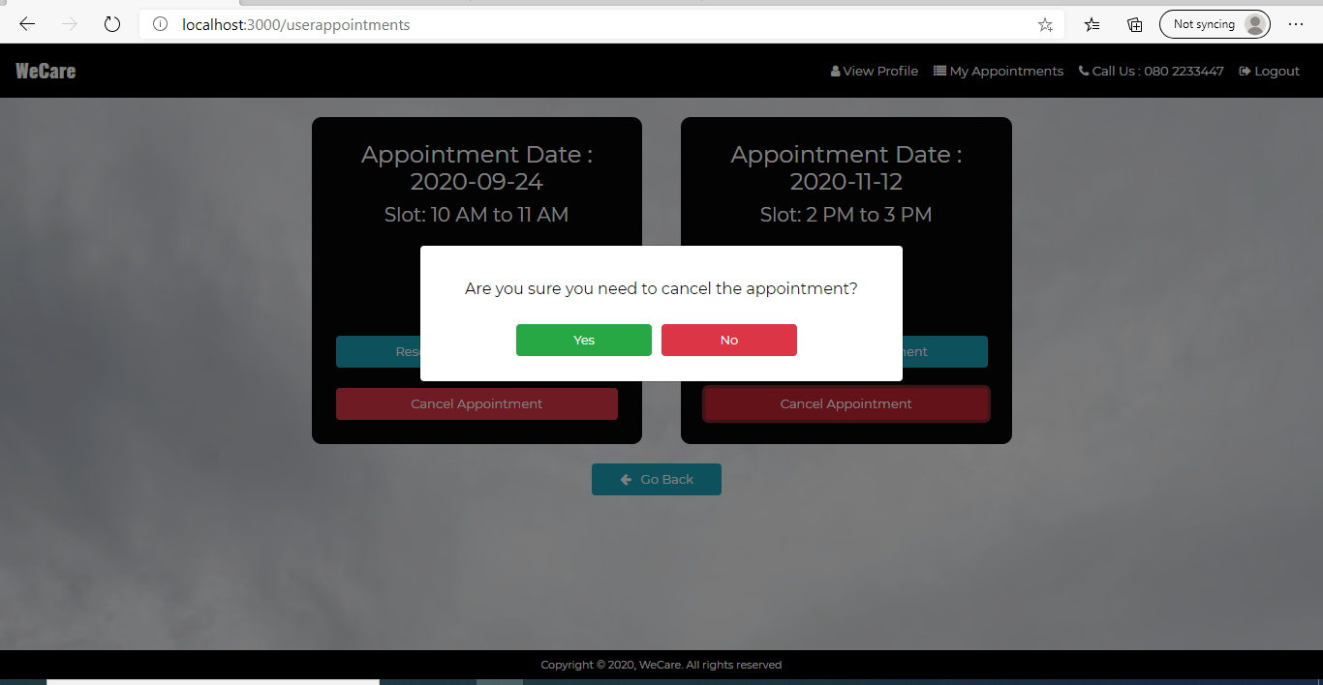

On successful deletion of appointment show the below page:

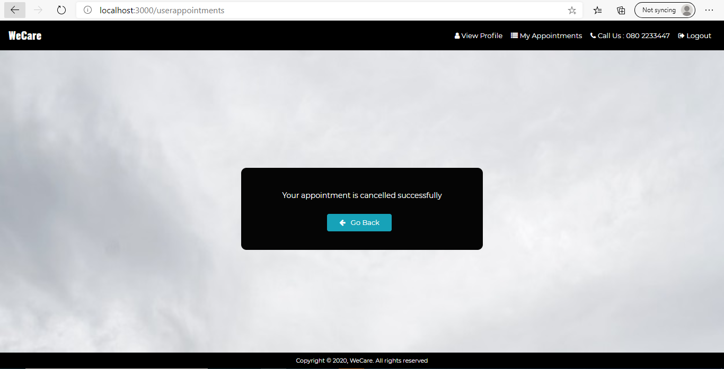

On clicking the go back button, it should navigate to userhome page where it displays the list of coaches.